COMP 370 Homework 7 – Web Scraping
Assigned Oct 24, 2025
Due Oct 31, 2025 @ 11:59 PM

Conceptual Exercises
- Why is the difference between found and designed data?
- What are the two primary challenges that necessitate sampling when collecting data?
- Why are website owners more likely to be upset about collecting data using scrapers than using APIs?

Technical Exercise
In this homework, we’ll be using web scraping to collect the 5 trending stories from the Montreal Gazette. Our objective is to collect the title, publication date, author, and opening “blurb” (as seen in the screen capture here).
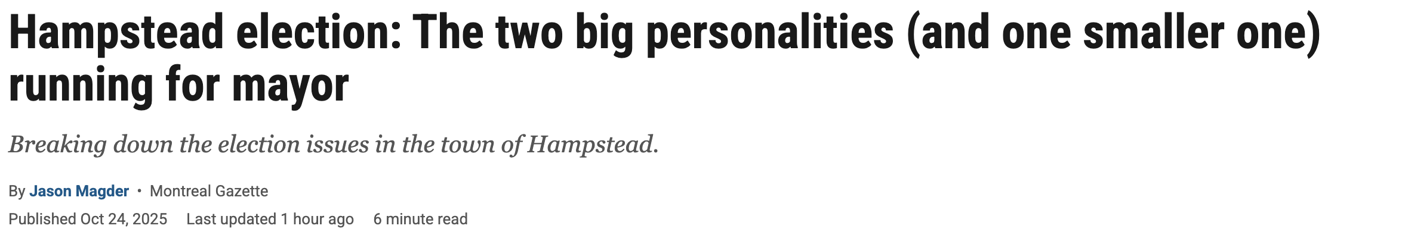
We want a script “collect_trending.py” that does all the work (i.e., we don’t have to specify the trending articles one-by-one or in a list. The script goes, figures out which they are, and then grabs them off the website).
So to do this, you’ll have to write a scraper script that works through two different page templates.
- To get the trending stories (and links to them), you’ll need to first scrape the homepage of Montreal Gazette (https://montrealgazette.com/category/news/)
- Then once you have links to the trending stories, you’ll need to scrape the key information off the article page itself.
collect_trending.py is run as follows:
python collect_trending.py -o trending.json
Such that trending.json has the format:
[
{
“title”: “article title”,
“publication_date”: “date”,
“author”: “author”,
“blurb”: “blurb”
},
{
… article info
},
…
]

For both page templates, use cache-ing to avoid overly taxing the Montreal Gazette website.

Submission Instructions
- Submit your conceptual answers in a file called conceptual_answers.md
- Submit all your code in a zip file code.zip (internal structure is up to you)

